**Assignment 1**

abstract class Shape2 {

    abstract void calculateArea();

}

class Circle2 extends Shape2 {

    double radius;

    Circle2(double  radius) {

        this.radius = radius;

    }

    @Override

    void calculateArea() {

        double area = Math.PI * radius * radius;

        System.out.println("Area of Circle: " + area);

    }

}

class Square2 extends Shape2 {

    double length;

    Square2(double length) {

        this.length = length;

    }

    @Override

    void calculateArea() {

        double area = length * length;

        System.out.println("Area of Square: " + area);

    }

}

class Shape2Main{

    public static void main(String[] args) {

        Circle2 circle = new Circle2(5);

        Square2 square = new Square2(4);

        circle.calculateArea();

        square.calculateArea();

    }

}

**OUTPUT:**

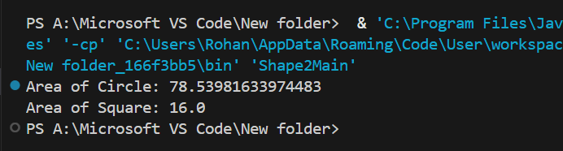

**Assignment 2**

import java.util.Scanner;

public class Animal2 {

    void makeSound() {

        System.out.println("The Animal makes sound");

    }

}

class Dog2 extends Animal2 {

    @Override

    void makeSound() {

        System.out.println("The Dog barks");

    }

}

class Cat2 extends Animal2 {

    @Override

    void makeSound() {

        System.out.println("The Cat meows");

    }

}

class Animal2Main{

    public static void main(String[] args) {

        System.out.println("Choose an Animal:");

        System.out.println("1. Dog");

        System.out.println("2. Cat");

        Scanner scanner = new Scanner(System.in);

        int choice = scanner.nextInt();

        switch(choice) {

            case 1:

                Dog2 dog = new Dog2();

                dog.makeSound();

                break;

            case 2:

                Cat2 cat = new Cat2();

                cat.makeSound();

                break;

            default:

                Animal2 animal = new Animal2();

                animal.makeSound();

                break;

        }

        scanner.close();

    }

}

**OUTPUT:**

